**Sets and Logics**

$$∈ - PART OF THE SET$$

≡ - Logical equality $∧ -And$ $∨$- OR

A is a data inside cluster C. A $∈$ C

B is a data inside cluster D B $∈d$

F is a data inside cluster E F $∈E$

H is a data inside cluster C in the crescendo sector G H $∈CDE$

L is a data inside Cluster E in crescendo sector I L $∈$ EC

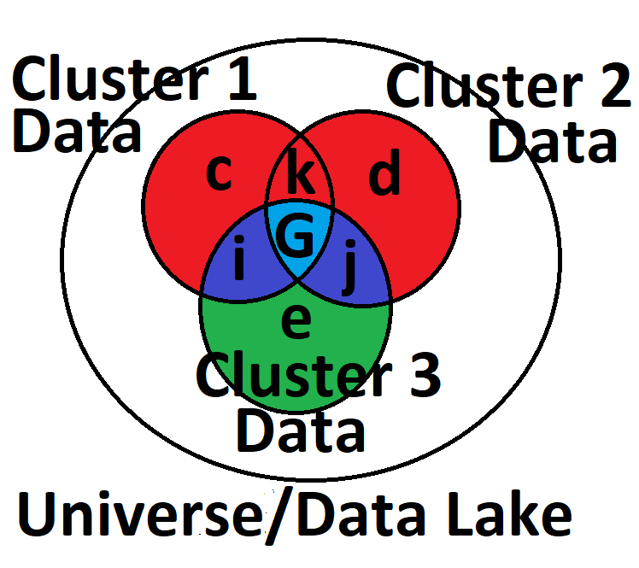

“Book of proof” by Hamnock – For discrete Math

**Truth Tables**

**P – is a true statement**

**Q – is a false statement**

**P $∨$**  **Q – True OR False**

**P $∧$ Q – True AND False**

|  |  |
| --- | --- |
| **P** | **Q** |
| **T** | **F** |
| **F** | **T** |

|  |  |  |  |  |
| --- | --- | --- | --- | --- |
| **P** | **P $∨$ P** | **P $∧$ P** | **T** | **F** |
| **T** | **T** | **T** | **T** | **F** |
| **F** | **F** | **F** | **T** | **F** |

**P**≡**P $∨$ P**≡**P $∧$ P**